Order Of Service

Singing: Psalm 32—CW page 78

Reading: Psalm 23

Opening Hymn: TLH 604

Reading: Revelation 6:9-17

Request Hymn: CW Supplement 702

Reading: John 6:16-24

Sermon Hymn: TLH 609

Sermon Text: Song Of Solomon 5:2

Flashback—Half Asleep

Prayer

The Apostles’ Creed, TLH page 12

Holy Communion

The Lord's Prayer

The Blessing

Closing Hymn: TLH 234

* * * * * * * * * * *

Bible Study: Lambs: Acts 9:1-9—A Light from Heaven
Sheep: Proverbs 11:11-21
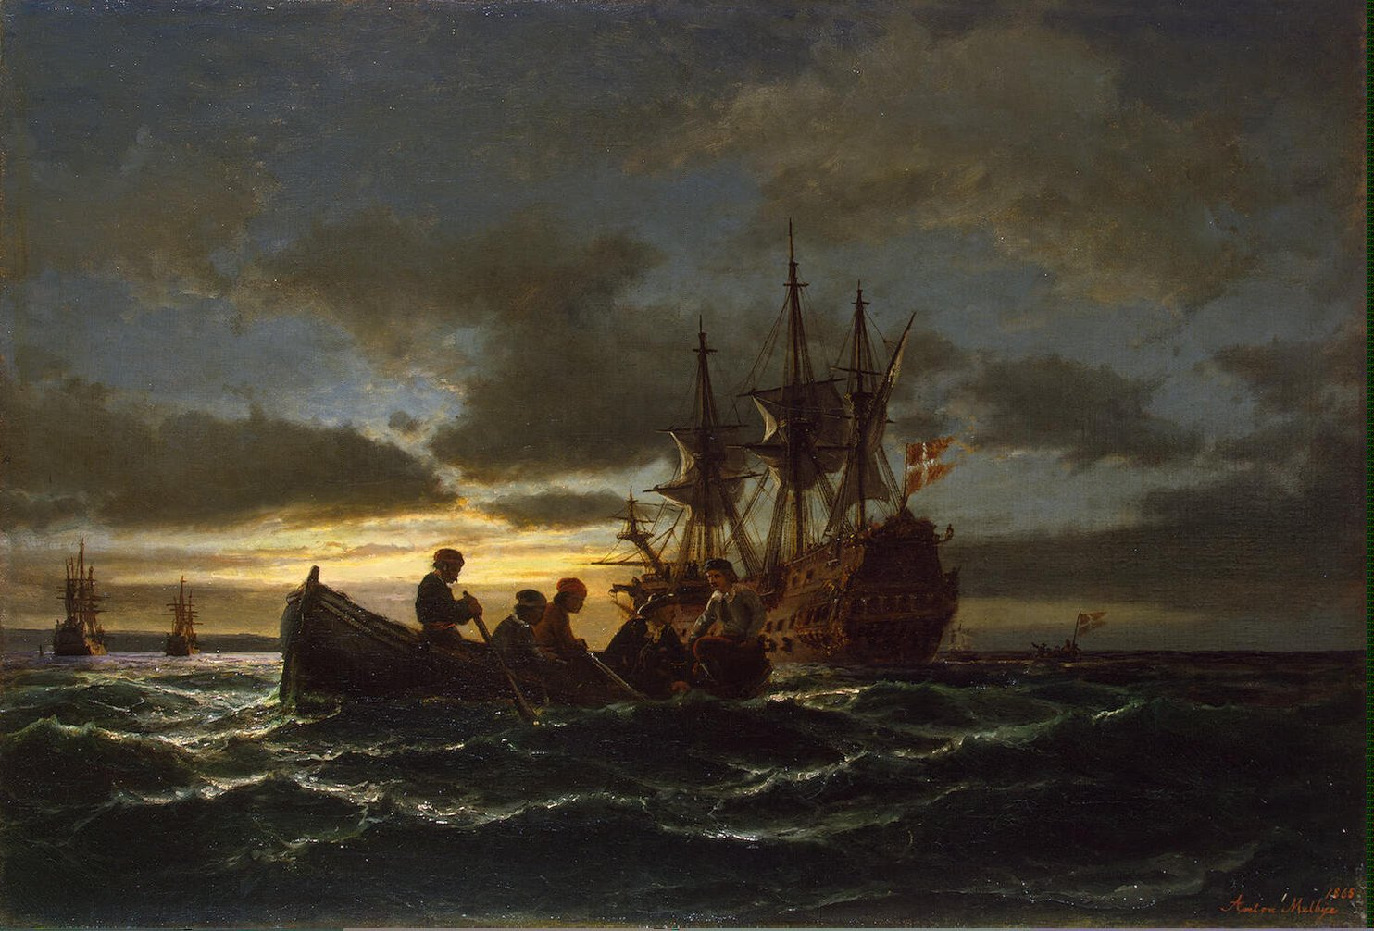

Another Night Scene

Water
Of
Life

13 November 2016

W A T E R O F L I F E

Independent Christian Church—Conservative Lutheran Doctrine

Worship Service: 9:30 a.m. Bible Study: 10:45 a.m.

Larry Cooper, Pastor E-Mail address:
111 N. Ridge Road lcooper@wateroflife.cc
Coon Valley, WI 54623 Web Site:
Phone: (608) 452-2105 www.wateroflife.cc

* * * * * * * * * * * * * * * * * * * * * * * * * * *

Sermon Text: Song Of Solomon 5:2

Flashback—Half Asleep

* * * * * * * * * * * * * * * * * * * * * * * * * * *

Song of Solomon 5:2 I sleep, but my heart waketh: it is the voice of my beloved that knocketh, saying, Open to me, my sister, my love, my dove, my undefiled: for my head is filled with dew, and my locks with the drops of the night.

This morning, in a flashback, the Holy Spirit unfolds to us another night scene. We could perhaps say that there are two Nocturnal Night Searches in Song Of Solomon. In both we see the Bride searching for her Bridegroom in the darkness of night.

The two Nocturnal Night Searches are found in 3:1-5 and 5:2-8. For reference:
Song of Solomon 3:1 By night on my bed I sought him whom my soul loveth: I sought him, but I found him not.
:2 I will rise now, and go about the city in the streets, and in the broad ways I will seek him whom my soul loveth: I sought him, but I found him not.
:3 The watchmen that go about the city found me: to whom I said, Saw ye him whom my soul loveth?
:4 It was but a little that I passed from them, but I found him whom my soul loveth: I held him, and would not let him go, until I had brought him into my mother's house, and into the chamber of her that conceived me.
:5 I charge you, O ye daughters of Jerusalem, by the roes, and by the hinds of the field, that ye stir not up, nor awake my love, till he please.

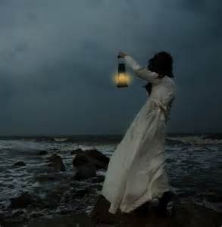

There are extremely instructive parallels and contrasts between these two night scenes. We’ll pray for the guidance of the Holy Spirit and explore them in the coming weeks—if the Lord Jesus doesn’t come back first, and if it is God’s will.

